APPLICATION
OF
CLUSTERING IN DATA MINING
ON
REALESTATE-HOUSING SALES DATA TABLE

: Clustering in Data Mining - Theory Introduction :

A Cluster:
A basic unit of a classification of initially unclassified data based on common properties.

A cluster is a set of entities that are alike, and entities from different clusters that are not alike.

A cluster is a aggregation of points in the test space such that the distance between any two points in the cluster is less than the distance between any point within the cluster and any other point outside the cluster.

Main Objectives:

Identify a group of data that meet one of the following two conditions:

- Groups whose members are very similar
( Similarity within criterion)
- Groups that are clearly separated from one another (Separation between criterion).

CLUSTERING PROCESS:

- Choose the target attributes to be used as our clustering criterion.
- Sort the attribute.
- Create clusters in the result table having each single value as separate cluster initially.
- Merge the clusters that have the shortest distances.
- Repeat step (iv) until the number of clusters become as desired threshold.
- Generate rules from resulting clusters and their characteristics.

[From handout by Dr.Suh]
: MY FOCUS :

GENERATING RULES,

SUCH AS SO AND SO FEATURED HOUSE SALE PRICE FALLS WHITHIN THIS X RANGE OF AMOUNT.

:Steps in brief:

A) Choosing target attribute and sort the attribute.
B) Create initial set of clusters with a single object.
C) Find Distances between any pair of clusters.
D) Using single-link method merge clusters until the required numbers.
E) Conclusion/What we mined.

(A)

Metadata of table under process: “RealEstate-Housing sales Data"

ATTRIBUTE |  | ATTRIBUTE DESCRIPTION
Address |  | Address, where the house located
Sale price |  | When it was sold, amount is in dollars
Sale date
Bedrooms |  | Number showing how many bedrooms the house having
Bathrooms |  | Number showing how many bathrooms the house having
Fireplaces |  | Number showing how many fireplaces the house having
Garage spaces |  | Number showing how many vehicles can be accomodated in Garage
Enclosed sq ft |  | Area of the Constuction, in sq ft.
Lot sq ft |  | Area of the Lot, in sq ft.
Subdivision
Basement |  | Fully furnished/ partially furnished /No basement
Source
Distance
Subdiv 11
Subdiv 13
Subdiv 16
Subdiv 18
Subdiv 36
Subdiv 106
Subdiv 502

I have chosen “Sale Price” as target attribute for clustering process.

Contents of the table (partial):

Sale price | Sale date | Bedrooms | Bathrooms | Fireplaces | Garage spaces | Enclosed sq ft
1500000 | 7/27/2004 | 5 | 4 | 2 |  | 3162
1200000 | 7/22/2004 | 4 | 4 | 1 | 2 | 2399
640000 | 9/21/2004 | 3 | 2 |  | 2 | 2067
1862500 | 8/3/2004 | 7 | 3 | 1 |  | 3370
1899000 | 8/9/2004 | 6 | 4 | 2 | 1 | 3833
1200000 | 8/19/2004 | 5 | 2 | 1 |  | 2100
1100000 | 8/23/2004 | 5 | 3 | 3 | 1 | 3188
1193005 | 8/18/2004 | 4 | 2 | 1 | 2 | 2268
935127 | 8/25/2004 | 4 | 2 | 1 | 1 | 1712
996500 | 9/8/2004 | 6 | 3 | 1 |  | 2490
1050000 | 9/7/2004 | 5 | 6 | 3 |  | 2668
840000 | 10/12/2004 | 5 | 4 | 1 | 2 | 1988
985000 | 10/7/2004 | 4 | 3 | 2 | 2 | 2256
1000000 | 10/21/2004 | 4 | 2 | 1 |  | 1408
1595000 | 11/9/2004 | 6 | 5 | 1 | 2 | 3529
1471250 | 12/20/2004 | 4 | 4 | 3 |  | 3040
1050000 | 12/10/2004 | 4 | 1 | 1 | 1 | 2406
1547500 | 12/30/2004 | 4 | 4 | 1 | 1 | 2269
1400000 | 3/11/2004 | 6 | 4 |  |  | 3678
1215000 | 5/12/2004 | 4 | 3 |  |  | 2277
1084000 | 6/28/2004 | 4 | 3 |  |  | 1980
1025000 | 10/6/2004 |  |  |  |  | 1846
1294000 | 3/4/2004 | 5 | 3 |  |  | 3671

Attribute
1500000 | 1500
1200000 | 1200
640000 | 640
1862500 | 1862
1899000 | 1899
1200000 | 1200
1100000 | 1100
1193005 | 1193
935127 | 935
996500 | 996
1050000 | 1050
840000 | 840
985000 | 985
1000000 | 1000
1595000 | 1595
1471250 | 1471
1050000 | 1050
1547500 | 1547
1400000 | 1400
1215000 | 1215
1084000 | 1084
1025000 | 1025
1294000 | 1294
1795000 | 1795
1355000 | 1355
1149000 | 1149
832000 | 832
967300 | 967
1110000 | 1110
1250000 | 1250
720000 | 720
780000 | 780
1500000 | 1500
915000 | 915
675000 | 675
870000 | 870
1940000 | 1940
703250 | 703
1883454 | 1883
675000 | 675
610000 | 610
840000 | 840
805000 | 805
1035000 | 1035
1220000 | 1220
715000 | 715
1636000 | 1636
610
640
675
675
703
715
720
780
805
832
840
840
870
915
935
967
985
996
1000
1025
1035
1050
1050
1084
1100
1110
1149
1193
1200
1200
1215
1220
1250
1294
1355
1400
1471
1500
1500
1547
1595
1636
1795
1862
1883
1899
1940
‘sale price ‘
is rounded into K
dollars.

Rightmost column
Shows sorted sale
Price in 1000
Dollars.

Total 47 rows.
(B)
Creating initial set of clusters with single object

Cluster ID Prize
C0 610
C1 640
C2 675
C3 675
C4 703
C5 715
C6 720
C7 780
C8 805
C9 832
C10 840
C11 840
C12 870
C13 915
C14 935
C15 967
C16 985
C17 996
C18 1000
C19 1025
C20 1035
C21 1050
C22 1050
C23 1084
C24 1100
C25 1110
C26 1149
C27 1193
C28 1200
C29 1200
C30 1215
C31 1220
C32 1250
C33 1294
C34 1355
C35 1400
C36 1471
C37 1500
C38 1500
C39 1547
C40 1595
C41 1636
C42 1795
C43 1862
C44 1883
C45 1899
C46 1940

(C)
Initial Distance Matrix between pair of clusters:

C0 C1 C2 C3 C4 C5 C6 C7 C8 C9 …
C0 0 30 65 65 93 105 110 170 195 222
C1 30 0 35 35 63 75 80 140 165 192
C2 65 35 0 0 28 40 45 105 130 157
C3 65 35 0 0 28 40 45 105 130 157
C4 93 63 28 28 0 12 17 77 102 129
C5 105 75 40 40 12 0 5 65 90 117
C6 110 80 45 45 17 5 0 60 85 112
C7 170 140 105 105 77 65 60 0 25 …
C8 195 165 130 130 102 90 85 25 0 …
C9 222 192 157 157 129 117 112 52 27 …
…
…

(D)

I have developed a c++ program to find above initial matrix.

For merging of clusters,

(i) The output of c++ program displays which clusters are to be merged.

(ii) Replacing one pair shown to merged by only single higher value of sale price.
For every pair of values do above after single execution of c++ program.

(iii) Resulting is a sorted data of less number of clusters. Repeat step (i) and (ii) till number of clusters reach the required.

I have set the number of clusters required as 5.

A tree like dendrogram of hierarchical clustering with single link method:
Cluster1
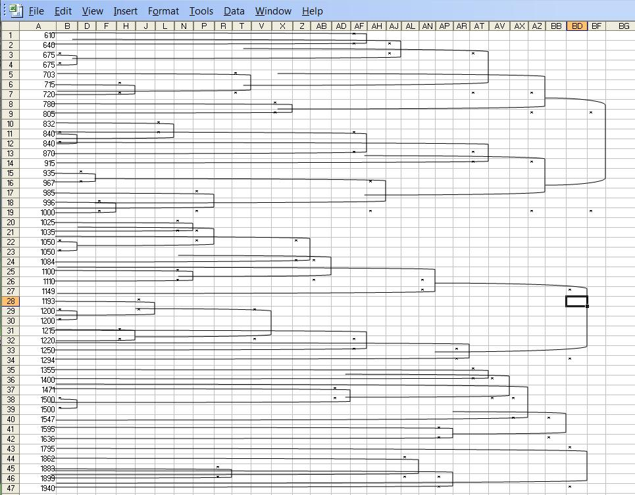

Cluster2

Critical value boundary line
Cluster3
Cluster4
Cluster5
(E)
Conclusion/What we mined.

Based on five clusters shown above, we can generate following rules:
Cluster3
Cluster4
Cluster5

(I) House having 0 to 3 Bedrooms,
0 to 2 Bathrooms,
No fireplace,
0 to 2 Garage space,
Enclosed in sq ft 1000 to 2000 and like
Features, sale price range is 610K to 805K.

(II) House having 4 to 6 Bedrooms,
2 to 4 Bathrooms,
1 to 2 fireplace,
1 to 2 Garage space,
Enclosed in sq ft 1500 to 2500 and like
Features, sale price range is 832K to 1000K.

(III) House having 4 to 5 Bedrooms,
4 to 6 Bathrooms,
2 to 3 fireplace,
1 to 2 Garage space,
Enclosed in sq ft 2000 to 3500 and like
Features, sale price range is 1025K to 1294K.

(IV) House having 4 to 5 Bedrooms,
4 to 6 Bathrooms,
2 to 3 fireplace,
1 to 2 Garage space,
Enclosed in sq ft 3000 to 3700 and like
Features, sale price range is 1355K to 1636K.

(V) House having 4 to 7 Bedrooms,
3 to 4 Bathrooms,
1 to 2 fireplace,
1 to 2 Garage space,
Enclosed in sq ft 3500 to 4700 and like
Features, sale price range is 1795K to 1940K.

Hence, with clustering classification/prediction can be supported.
Cluster2

